**LOG BOOK**

**KERJA PRAKTEK (KP)**



**Judul : SISTEM INFORMASI DATA IUP**

**(IZIN USAHA PERTAMBANGAN)**

**BERBASIS WEB DI DINAS**

**ENERGI DAN SUMBER DAYA**

**MINERAL PROVINSI RIAU**

**Nama : DINA LOVITA SARI**

**NIM : 1407122156**

**Pembimbing Lapangan : ANTON SUPROJO HADIYANTO, ST**

**Dosen Pembimbing : IRSAN TAUFIK ALI, ST.,MT**

**PROGRAM STUDI TEKNIK INFORMATIKA S1**

**JURUSAN TEKNIK ELEKTRO**

**UNIVERSITAS RIAU**

**2017**

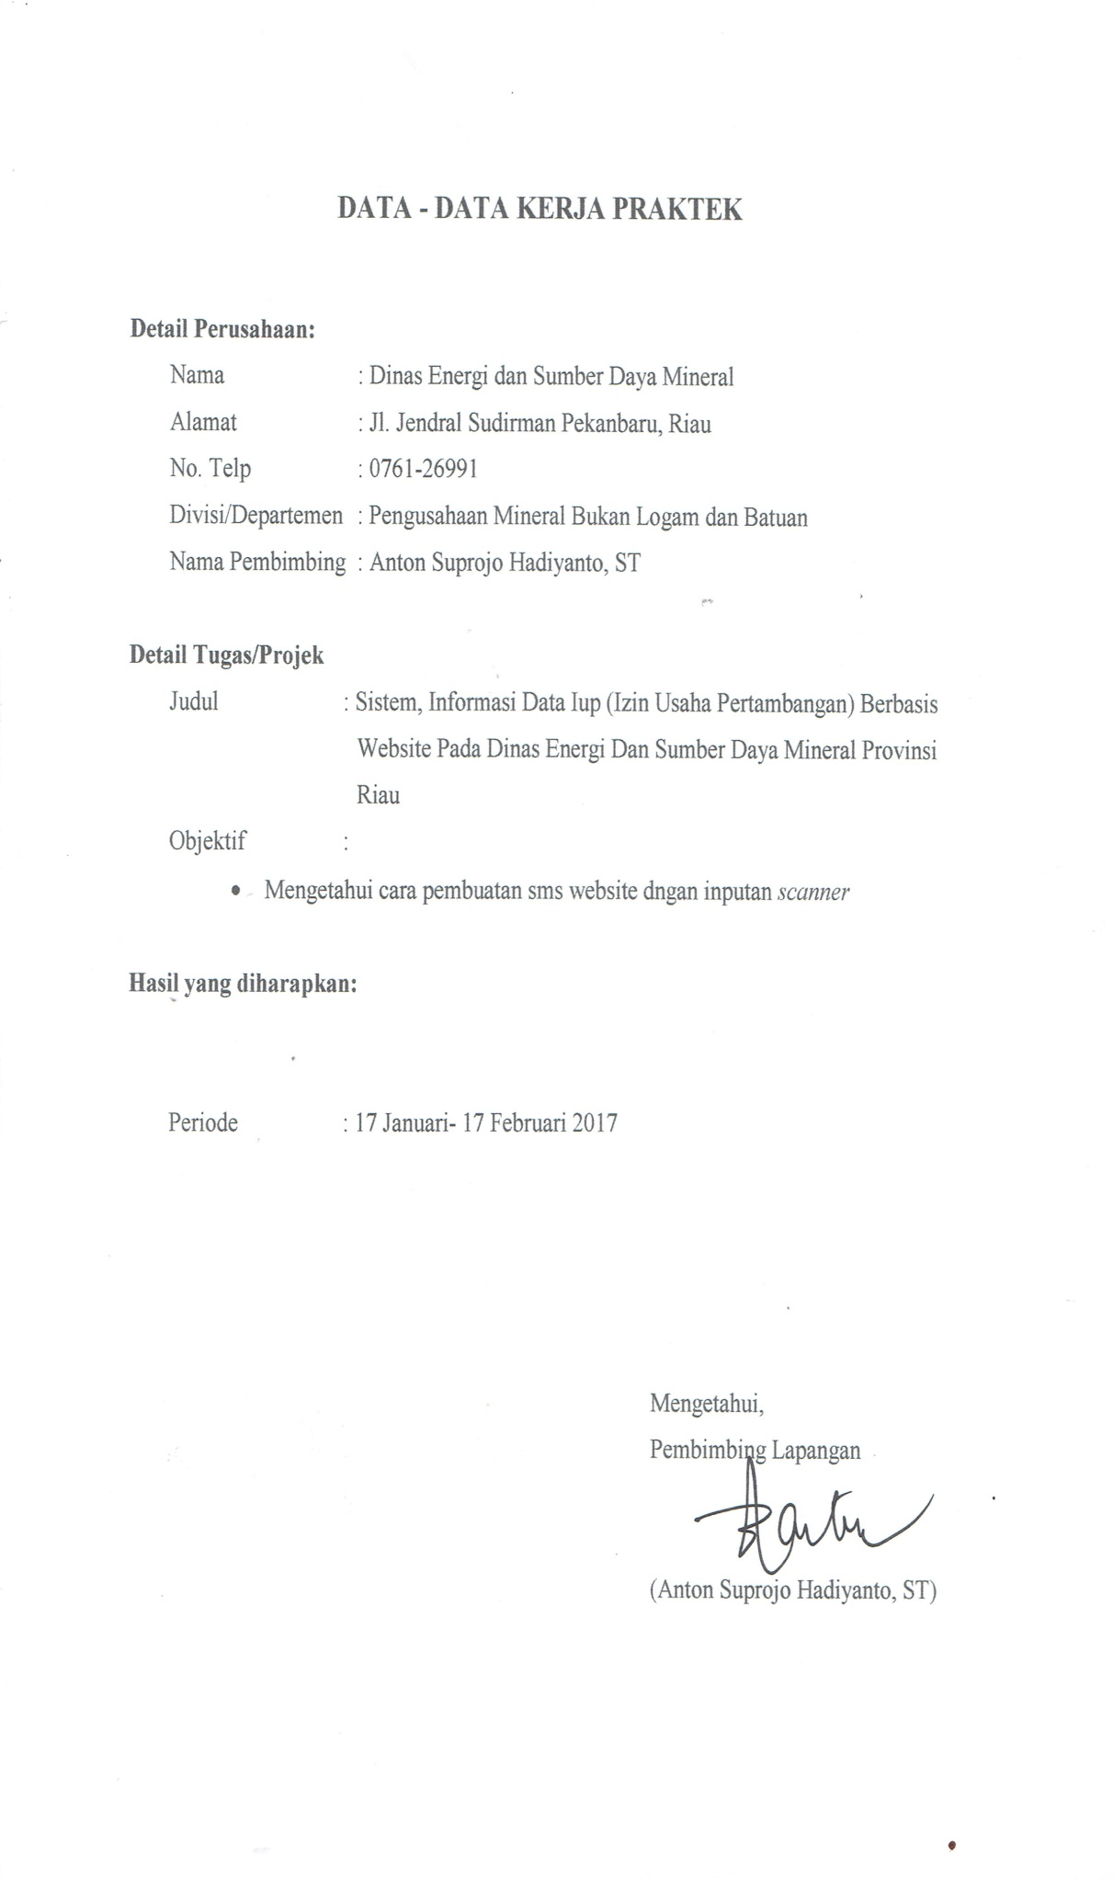

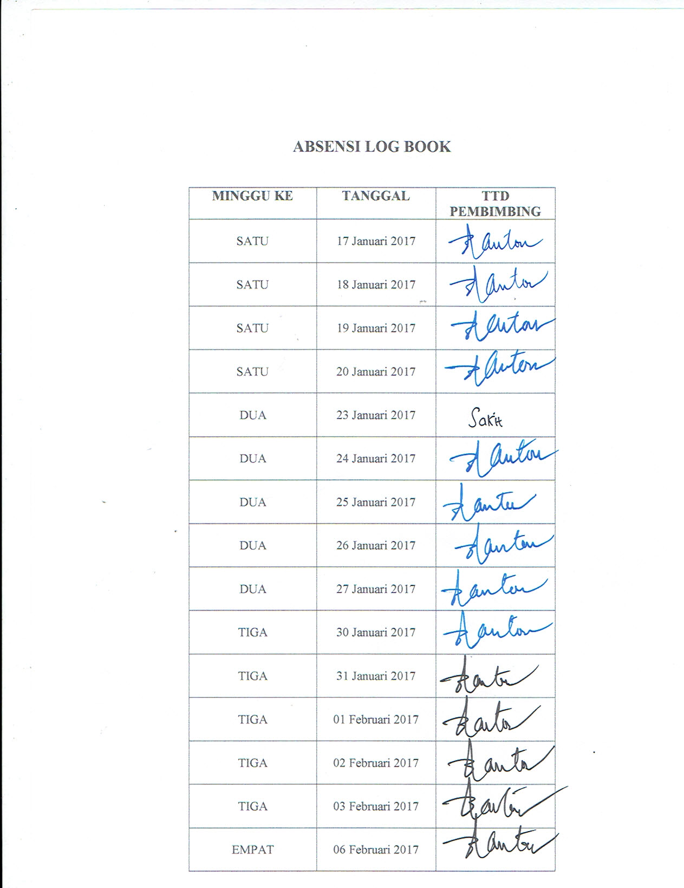

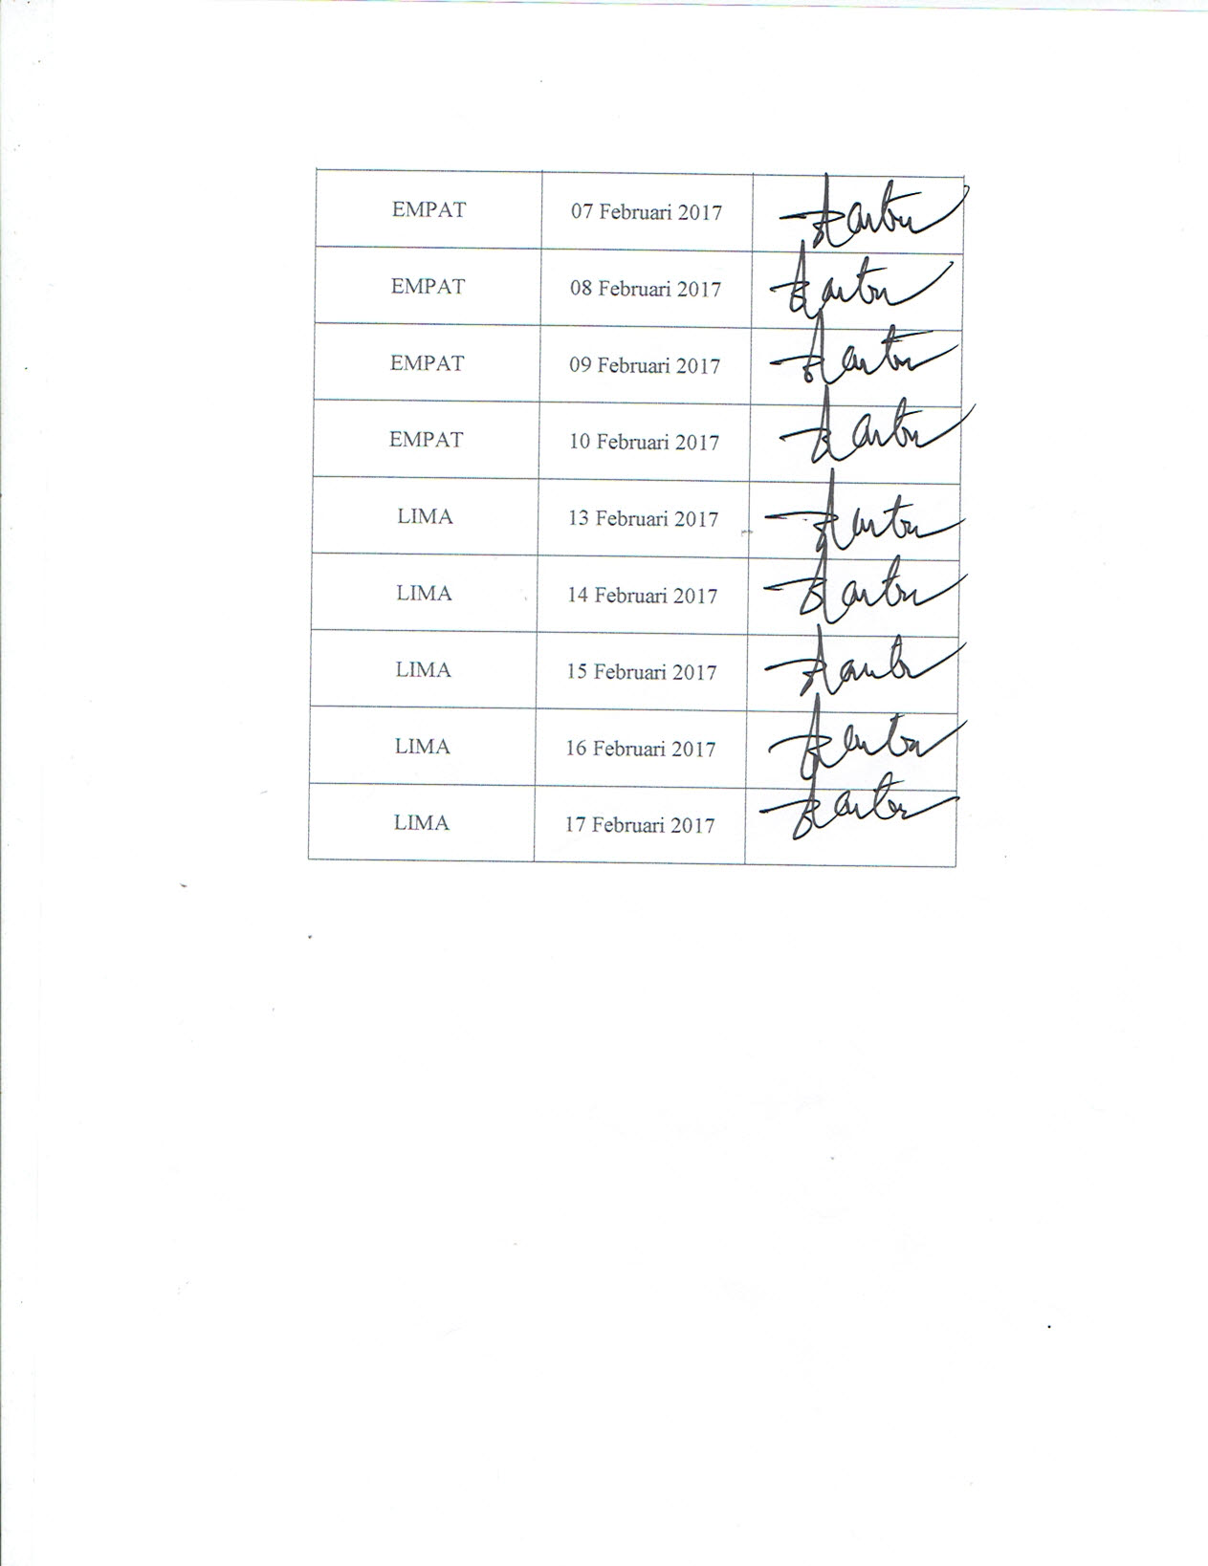

|  |  |  |  |  |  |  |  |  |  |  |  |  |  |  |  |  |  |  |  |  |  |  |  |  |  |  |  |  |  |  |  |
| --- | --- | --- | --- | --- | --- | --- | --- | --- | --- | --- | --- | --- | --- | --- | --- | --- | --- | --- | --- | --- | --- | --- | --- | --- | --- | --- | --- | --- | --- | --- | --- |
| **GRANT CHART KEGIATAN KERJA PRAKTEK** | | | | | | | | | | | | | | | | | | | | | | | | | | | | | | | |
|  |  |  |  |  |  |  |  |  |  |  |  |  |  |  |  |  |  |  |  |  |  |  |  |  |  |  |  |  |  |  |  |
| **AKTIFITAS** | | HARI | | | | | | | | | | | | | | | | | | | | | | | | | | | | | |
| 1 | 2 | 3 | 4 | 5 | 6 | 7 | 8 | 9 | 10 | 11 | 12 | 13 | 14 | 15 | 16 | 17 | 18 | 19 | 20 | 21 | 22 | 23 | 24 | 25 | 26 | 27 | 28 | 29 | 30 |
| 1. | Pengenalan Ruang Lingkup di Dinas Energi dan Sumber Daya Mineral seksi Sistem Informasi Geografis (SIG) |  |  |  |  |  |  |  |  |  |  |  |  |  |  |  |  |  |  |  |  |  |  |  |  |  |  |  |  |  |  |
| 2. | Pengenalan semua web yang ada di Dinas Energi dan Sumber Daya Mineral |  |  |  |  |  |  |  |  |  |  |  |  |  |  |  |  |  |  |  |  |  |  |  |  |  |  |  |  |  |  |
| 3. | LIBUR |  |  |  |  |  |  |  |  |  |  |  |  |  |  |  |  |  |  |  |  |  |  |  |  |  |  |  |  |  |  |
| 4. | Menganalisis Kekurangan semua Web yang ada di Dinas Energi dan Sumber Daya Mineral |  |  |  |  |  |  |  |  |  |  |  |  |  |  |  |  |  |  |  |  |  |  |  |  |  |  |  |  |  |  |
| 5. | Menganalisis Kinerja Pengolahan Data yang belum terintegrasi dengan teknologi di Dinas Energi dan Sumber Daya Mineral |  |  |  |  |  |  |  |  |  |  |  |  |  |  |  |  |  |  |  |  |  |  |  |  |  |  |  |  |  |  |
|  | LIBUR |  |  |  |  |  |  |  |  |  |  |  |  |  |  |  |  |  |  |  |  |  |  |  |  |  |  |  |  |  |  |
|  | Menemukan Permasalahan Pengolahan Data yang belum terintergrasi dengan Teknologi yaitu Pengelolaan Data IUP |  |  |  |  |  |  |  |  |  |  |  |  |  |  |  |  |  |  |  |  |  |  |  |  |  |  |  |  |  |  |
|  | Menganalisis Sistem seperti apa yang akan membantu Pengelolaan Data IUP |  |  |  |  |  |  |  |  |  |  |  |  |  |  |  |  |  |  |  |  |  |  |  |  |  |  |  |  |  |  |
|  | LIBUR |  |  |  |  |  |  |  |  |  |  |  |  |  |  |  |  |  |  |  |  |  |  |  |  |  |  |  |  |  |  |
|  | Membuat Database yang dibuat media non computer dan mendiskusikan kepada Pembimbing Lapangan |  |  |  |  |  |  |  |  |  |  |  |  |  |  |  |  |  |  |  |  |  |  |  |  |  |  |  |  |  |  |
|  | Membuat ERD,DFD,Diagram Konteks serta mendiskusikan hasilnya kepada Pembimbing Lapangan |  |  |  |  |  |  |  |  |  |  |  |  |  |  |  |  |  |  |  |  |  |  |  |  |  |  |  |  |  |  |
|  | LIBUR |  |  |  |  |  |  |  |  |  |  |  |  |  |  |  |  |  |  |  |  |  |  |  |  |  |  |  |  |  |  |
|  | Membuat Database di XAMPP |  |  |  |  |  |  |  |  |  |  |  |  |  |  |  |  |  |  |  |  |  |  |  |  |  |  |  |  |  |  |
|  | Membuat Design Interface Web, serta menyelaraskan dengan Database |  |  |  |  |  |  |  |  |  |  |  |  |  |  |  |  |  |  |  |  |  |  |  |  |  |  |  |  |  |  |
|  | Presentasi Hasil Pembuatan Web di Dinas Energi dan Sumber Daya Mineral Proinsi Riau |  |  |  |  |  |  |  |  |  |  |  |  |  |  |  |  |  |  |  |  |  |  |  |  |  |  |  |  |  |  |

